Saskatchewan Cup Road - 2024

Race Manual

Dates: Saturday, June 22, 2024 and Sunday, June 23, 2024
Hosted by Regina Cycle Club

Race Organizers:
Marshall Wilson, marshallw@gmail.com, 306-551-5080
Ben Hamilton, bencamham@gmail.com

Last updated: June 15, 2024;Version 1.3.0
The Latest Version of the Race Manual will be linked on the Facebook events page. Please refer to the latest manual for current rules. Any major updates will be posted on the Facebook page.

Facebook: https://www.facebook.com/groups/ReginaCycle/
Website: http://www.reginacycleclub.ca

We acknowledge the city of Moose Jaw and the city of Regina are located on the traditional territories of the nêhiyawak, Anihšināpēk, Dakota, Lakota, and Nakoda, and the homeland of the Métis/Michif Nationm, on Treaty 4 lands. We seek to live, work and play in ways that honour and respect the spirit of the treaties and the lives of our Indigenous neighbours.

Event information:
General information
- All racers will be required to sign a waiver either online or on race day
- For racers under the age of 18 years, a parent or guardian must sign the waiver
- Wearing rigid safety headgear is mandatory during competition and training sessions for all stages
- Urinating in public is strictly forbidden
- Even if you have preregistered for the race, you must present your race license and pick up your race numbers, RFID chip and race package now or you will not be allowed to race. Refunds will not be given to riders who miss sign on.
- E-bikes or pedal assisted bikes are not allowed. Use of an e-bike, pedal assisted bike, or motor will result in immediate disqualification.
- Time Trial (TT) bikes and/or aerobars are not allowed during any event.
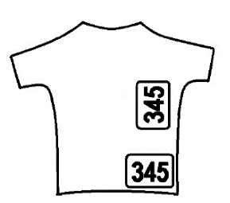
- Two race numbers will need to be worn on the right jersey pocket and right chest back. Numbers may not be folded, cut, covered, or overlapped. Race numbers need to be clearly visible to the commissaires.
- Wearing rigid safety headgear is mandatory during competition and training sessions for all stages
- A race timing chip must be affixed to your helmet.
- Cost:
  - The Criterium and Road race $30 if you register before June 15, 2023, at 11:00 pm, online.
  - The Elimination race will cost $10, if you register before June 15, 2023, at 11:00 pm, online.
  - For all three events, the cost will be $55.
  - For two events (Criterium and Road Race), the cost will be $50.
  - For two events (either Criterium or Road Race and Elimination race), the cost will be $35.
  - Otherwise, the Criterium and Road Race will cost $35, or $65 for both, for registrants at time of the race. The Elimination race will cost $15, or $40 for two (Elimination + Other event). All three events will cost $75.
- Online Registration will be available through CCN via the link below: https://ccnbikes.com/#!/events/24389-regina-cycle-club-saskatchewan-cup
- No race radios or remote communication devices are allowed.
Category registration:
- For Men: CAT 1, 2, 3 (Combined), CAT 4, and CAT 5
- For Women: May choose CAT 4 or CAT 5

Omnium Points:
- To qualify for the overall Omnium win, riders must finish each race.
- Riders regardless of overall eligibility for the overall Omnium standing will receive points as per below table.
Place | Criterium Points | Elimination Points | Road Race Points
1 | 25 | 25 | 25
2 | 20 | 20 | 20
3 | 10 | 10 | 10
4 | 8 | 8 | 8
5 | 7 | 7 | 7
6 | 6 | 6 | 6
7 | 5 | 5 | 5
8 | 4 | 4 | 4
9 | 3 | 3 | 3
10 | 2 | 2 | 2
11+ | 1 | 1 | 1

Volunteers:
We will need volunteers to make this happen. Please contact us directly by email, marshallw@gmail.com if you are interested.

Stage #1 – Road Race

Date: Saturday, June 22, 2023
Course: Highway 363 – Moose Jaw, SK
Strava Route:
Cat 1/2/3/5 : https://www.strava.com/routes/3220983173244554374
Cat 4: https://www.strava.com/routes/3221203821052363880

Registration: 9:30 am
Race Times:
10:30 am | 2 laps; 104 km | Cat 1 / 2 / 3
10:35 am | 76 km (Different Turnaround Point) | Cat 4/Women
10:40 am | 1 lap, 52 km | Cat 5/Women

Details:
- Parking and Staging will be at the Church of the Our Lady, 566 Vaughn Street
- Bathrooms are available before 10:30 AM in the community entrance of the Church of Our Lady. The bathrooms are through the door, first two doors on the right. Please do not use the church entrance. Bathrooms will be unavailable after the race.
- Start lists will be posted near the start line of the Road Race area.
- Two race numbers must be worn, as per the diagram in the Technical Guide General Information section above. Numbers may not be folded, cut, overlapped or covered.
- Chief Commissaire, in collaboration with the race organizers reserve the right to combine starts and modify courses as required.
- Racers who ride on or cross over the center line will be penalized 1 minute for each time that a Commissaire or designate observes them crossing the center line for any reason. Racers are not allowed to cross the center line in an attempt to pass the pack or gain an advantage and should not put themselves in a position that they could get “pushed” over the center line while trying to draft. Commissaires are instructed to be very strict with this rule, for your own safety and in the best interest of all competitors.
- Any rider must ride in their own category. Should a racer catch up to a racer in another category or get passed by a racer in another category, they must not ride with them.
- Cat 4 racers have a different turnaround point further down the road than the other Cats; please refer to the maps on the following page.
- All turnaround points will be marked with pylons, signs and if possible, Corner Marshals.
Parking
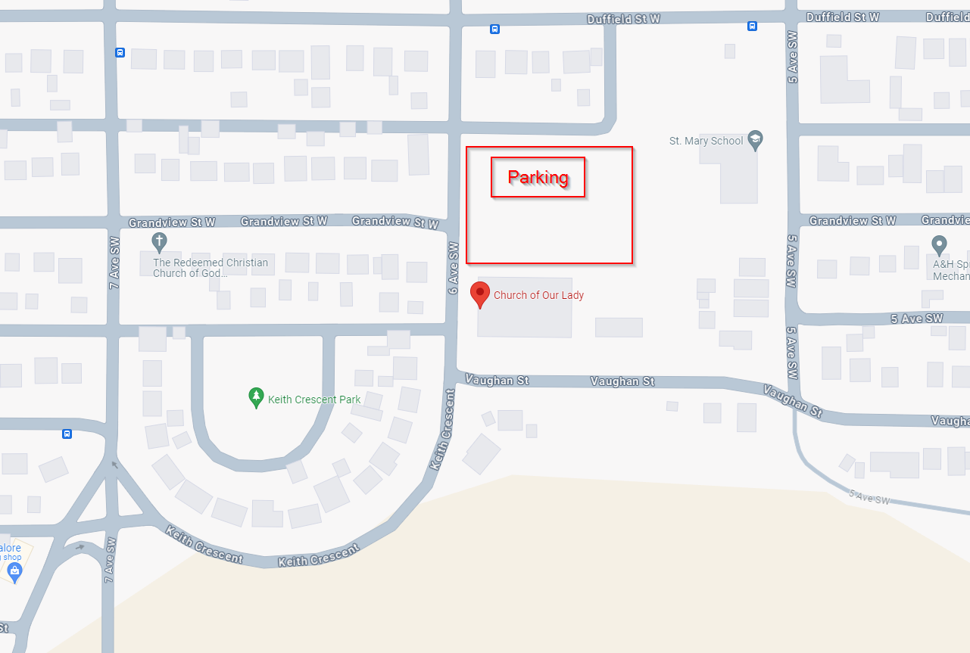

Route to Start Line
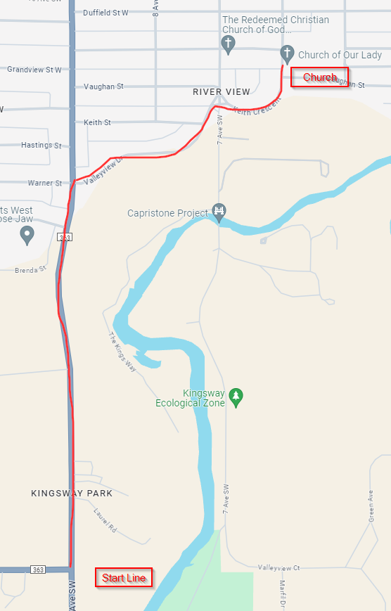
Cat 1/2/3/5 Course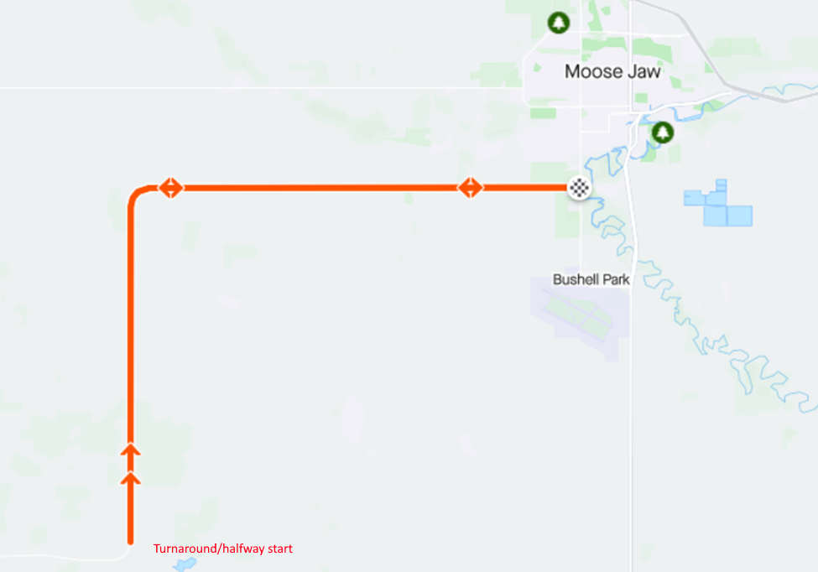

Cat 4 Course
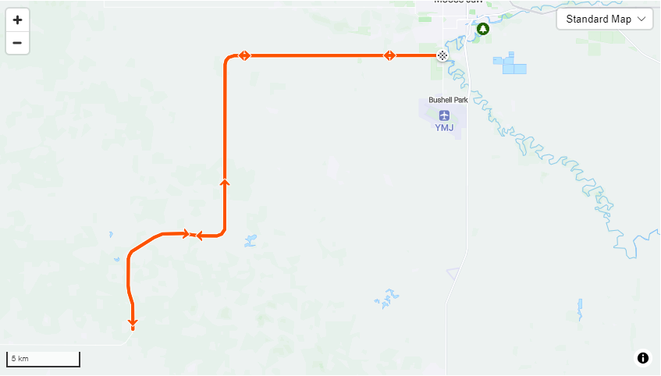
Stage #2 – Criterium

Date: Sunday, June 23, 2024
Course: King’s Park Speedway, Regina, SK
Strava Route:
Cat 1/2/3 : https://www.strava.com/routes/3220977661505023110

Registration: 9:30 am
Race Times:
10:30 am | 25 minutes plus 3 laps | CAT 5
11:15 am | 35 minutes plus 3 laps | CAT 4
12:00 am | 50 minutes plus 3 laps | CAT 1/2/3

Details:
- This is a 0.5 km Criterium looping clockwise around the King’s Park Speedway near Regina.
- Parking will be available at King’s Park Speedway
- UCI rules and regulations will be in place.
- All racers will finish on the same lap as the leader, regardless of the number of laps completed.
- Lapped riders will be pulled at the Commissaire’s discretion. Pulled riders will be given a pro-rated time. Riders who do not finish (DNF) on their own will not be given a prorated time. All racers will finish on the same lap as the leader, regardless of number of laps completed.
- There will be a wheel pit near the Start / Finish line for riders who have crashed or flatted. Wheels in the pit will be neutral wheels. Please label wheels with your name, race number and the gear. Riders may cut the course to access this wheel pit but may not ride backwards on the course.
- Riders will be given a free lap for a flat or crash-related mechanical up to the last three laps. Each person is only allowed one free lap/race. Any rider who crashes in the last three laps will be given the same time as the last rider in the group they were riding in prior to the incident.
- Chief Commissaire, in collaboration with the race organizers reserve the right to combine starts and modify courses as required.
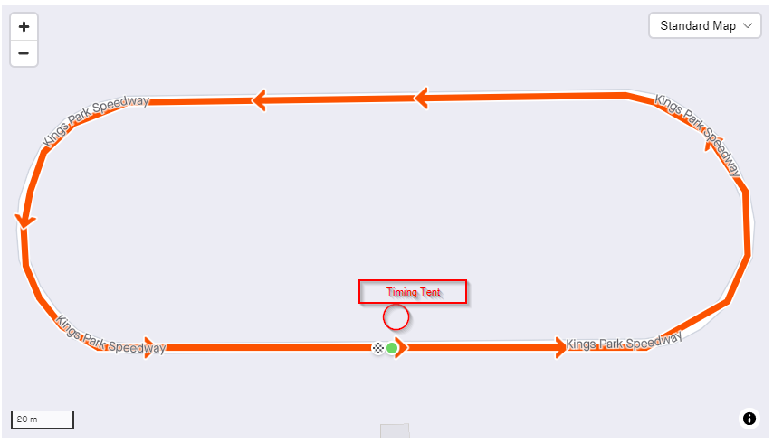
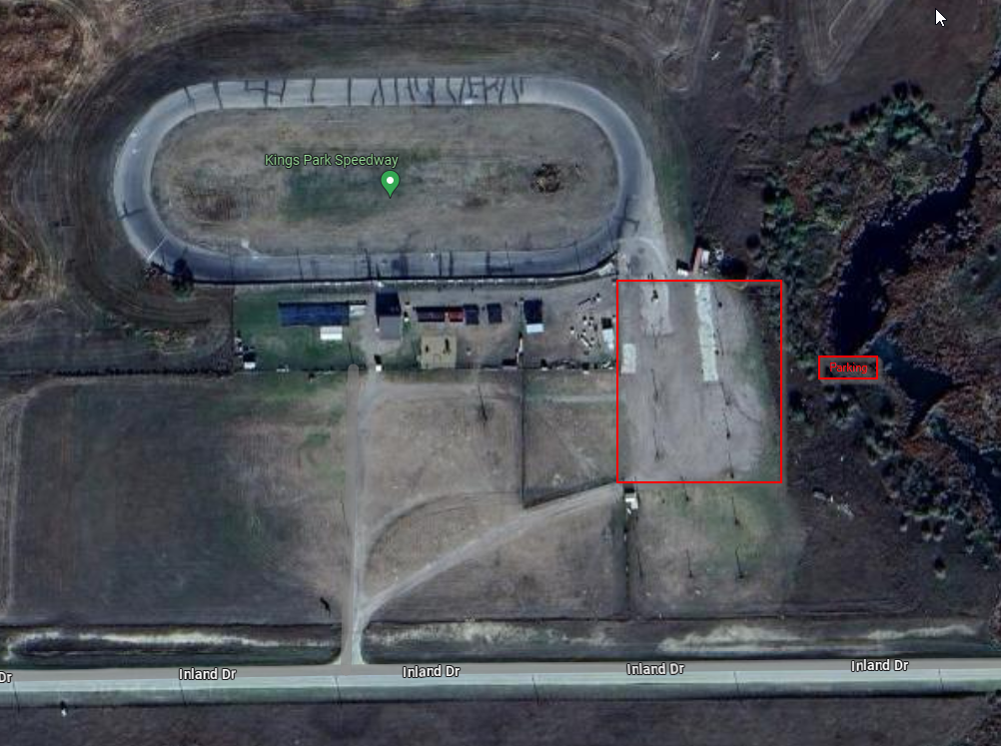

Extra Event – Open Track
Date: Sunday, June 23, 2023
Course: King’s Park Speedway, Regina, Saskatchewan
Strava Route: https://www.strava.com/routes/3220977661505023110

Times: 12:45 PM – 1:45 PM

Details:
- This is an open time slot, available for a recreational ride on a closed circuit for anyone interested.
- Family members of registered racers will be allowed on the track.

Stage #3 – Elimination Race
Date: Sunday, June 23, 2023
Course: King’s Park Speedway, Regina, Saskatchewan
Strava Route: https://www.strava.com/routes/3220977661505023110

Registration: 12:00 pm
Race Times:
2:00 | 10 minutes then Elimination every 2nd lap | Cat 5
2:30 | 10 minutes then Elimination every 2nd lap | Cat 4
3:00 | 15 minutes then Elimination every 2nd lap | Cat 1/2/3

Details:
- Sign on and start will occur at King’s Park Speedway
- Parking is available at King’s Park Speedway
- Washrooms are available at King’s Park Speedway
- There will be a wheel pit near the Start / Finish line for riders who have crashed or flatted. Wheels in the pit will be neutral wheels. Please label wheels with your name, race number and the gear. Riders may cut the course to access this wheel pit but may not ride backwards on the course.
- Lapped riders will be pulled at the Commissaire’s discretion. Pulled riders will be given a pro-rated time. Riders who do not finish (DNF) on their own will not be given a prorated time. All racers will finish on the same lap as the leader, regardless of number of laps completed.
- Riders will be given a free lap for a flat or crash-related mechanical up to the last three laps. Each person is only allowed one free lap/race. Any rider who crashes in the last three laps will be given the same time as the last rider in the group they were riding in prior to the incident.
- Chief Commissaire, in collaboration with the race organizers reserve the right to combine starts and modify courses as required.
- Once the appropriate amount of time has passed, every second lap will result in the last rider being eliminated from the race. They will be flagged and will need to leave the course.
- Once there are only 4 racers left, they will race 2 more laps to the finish line.
  - If there are 6 or fewer racers, they will race until there are only 2 racers left. Then the remaining two racers will race 2 more laps to the finish line.

